BIRLA INSTITUTE OF TECHNOLOGY & SCIENCE, PILANI
First Semester (2023-24)
Assignment-2

Course No. CE F211 Course Title: Mechanics of Solids
Q.1 A rigid bar ACDB is hinged at point A and it is supported by two identical springs having spring constants ks₁ and ks₂ as shown in Fig Q1. Calculate the spring force at point C & D and also find the relation between ks₁ and ks₂.
2 m  2 m  1 m  P = 30 kN  A  C  D  B  S₁  S₂  Fig.Q1 | 4 cm²  5 cm²  125 cm  125 cm  100 kN  1 mm  A  B  C  D  Fig.Q2
Q.2 A Steel bar as shown in Fig.Q2consists of two parts AB and BC having areas of cross-section 4 cm² and 5 cm² respectively. It is rigidly fixed at end A. End C is at a distance of 1 mm from the other rigid horizontal support D. A load of 100 kN is applied vertically downward at B. Determine the reactions produced by the rigid horizontal support D and the stress in the part AB and BC of the bar. E = 200 GPa.
Q.3 The truss (Fig.Q3) consists of three members each made of steel (E = 205 × 10⁶ KN/m²) and having a cross sectional area of 4.84 cm². Applying the energy method determine the greatest load P that can be applied so that the roller support at C is not displaced more than 0.8 mm.
20 cm
Q.4 A rigid bar (FigQ.4) AC is supported by three rods in the same vertical plane and equidistant. The outer rods are of Brass and of length 40 cm and dia. 2 cm. The central rod is of steel of 60 cm length and of 2.5 cm diameter. Calculate the forces in the bars due to an applied load P, if the bar AC remains horizontal after the load has been applied. Take E_{s}/E_{b} = 2.

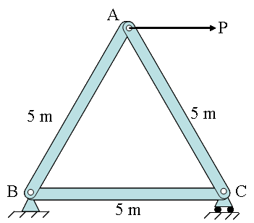  Fig.Q3 | 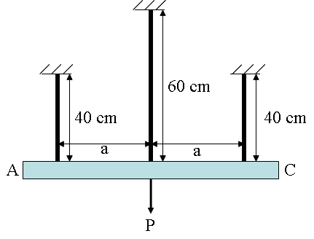  Fig.Q4

Q5. FigQ5 shows a rigid bar ABC hinged at A and suspended at two points B and C by two bars BE and CD made of aluminium and steel respectively. The bar carries a central load 20 kN midway between B and C. The cross sectional area of aluminium bar BD is 3 sq mm and that of steel bar CE is 2 mm² . Determine the load taken by the two bars BD and CE. Given that E_{a} = 7 X 10⁷ N/mm² and E_{s} = 2 X 10⁵ N/mm² | B  C  E  D  1 m  1 m  Fig.Q5  A
Q.6 Members AB and BC are made of steel (E = 200 GPa) withcross-sectional areas of 516 mm2 and 412 mm2,respectively. For the loading shown (Fig.Q7), determinethe elongation of  (a) member AB,  (b) member BC. |  | 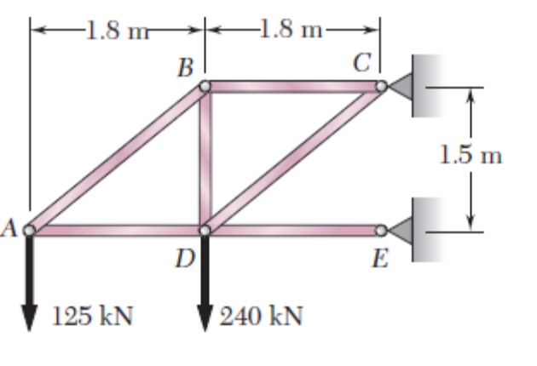  Fig.Q6

